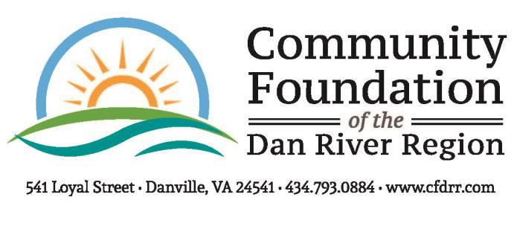
2022 FINAL GRANT REPORT FORM
Please complete and return upon 30 days of completion of the project but no later than December 16, 2022 to The Community Foundation, Attn: Katherine Milam, 541 Loyal Street, Danville, VA, 24541.

Reporting Organization:

Project Purpose:

Amount of Grant:
Date of Grant:

- Fiscal Report: How were the funds expended? Please be as specific as possible by attaching a summary of expenses along with copies of cancelled checks and receipts. Any remaining or unaccounted for funds must be returned to the Community Foundation by December 16, 2022, as stated in the Performance Grant Agreement that your Board President signed.
- Impact Statement: Please describe the impact the Foundation's grant had on your program as well as the community as a whole. Attach one additional sheet of paper explaining the impact of these funds. Be specific. Give Examples. Address the following:

  - Need or opportunity that was met or problem solved.
  - Outcomes including increased knowledge or changed behavior and measurements used.
  - Challenges encountered with the project/program and how they were addressed.
  - Additional information or comments.

- Program Population Served Report: The Foundation requires demographic data for the population served by your grant-funded program/project. Please submit the total number of people served, and break this information down by race, age, and gender. An editable Population Served Report Form is available on our website, and organizations should use this form to complete the requirement.

Video: Provide a brief (less than three minutes) video discussing the program for which you received funding and the impact it had on the organization and community as a whole. If the organization needs assistance with recording the video, contact The Foundation’s office no later than Monday, December 5, 2022.

Photos: If available, please send project or general photos of your organization. E-mail photos to traci@cfdrr.org, or mail a hard copy to The Foundation’s office.

- Provide a one or two sentence statement sharing how this grant has changed or touched lives.

________________________________________________________________________________________

________________________________________________________________________________________

This form is available for download as a Microsoft Word document at https://www.cfdrr.org/grants/applying-for-a-grant/

Person completing form: _______________________________________ Title: __________________________

Phone: ________________________Email: _____________________________ Date: ___________________

