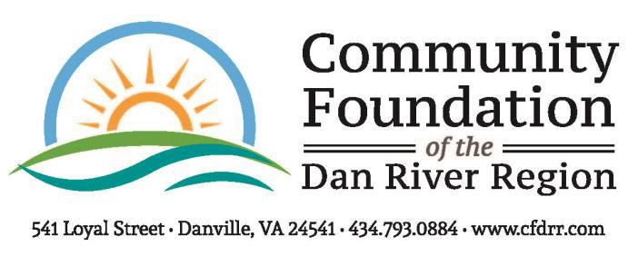

2020 FINAL GRANT REPORT FORM
Please complete and return upon 30 days of completion of the project but no later than December 18, 2020 to The Community Foundation, Attn: Krystal Davis, 541 Loyal Street, Danville, VA, 24541.

Reporting Organization:

Project Purpose:

Amount of Grant:
Date of Grant:

- Fiscal report: How were the funds expended? Please be as specific as possible by attaching a summary of expenses along with copies of cancelled checks and receipts. Any remaining or unaccounted for funds must be returned to the Community Foundation by December 18, 2020, as clearly stated in the Grant Agreement that your Board President signed.

- Impact Statement: Please describe the impact the Foundation's grant had on your program as well as the community as a whole. Attach one additional sheet of paper explaining the impact of these funds. Be specific. Give Examples. Address the following:

  - Need or opportunity that was met or problem solved.
  - Outcomes – this includes increased knowledge or changed behavior and measurements used.
  - Challenges encountered with the project/program and how they were met, etc.
  - Additional information or comments.

- Provide a one or two sentence statement sharing how this grant has changed or touched lives.

Send photos of your grant project or general photos of your organization. Enclose a hard copy of the photo(s) or E-mail them to krystal@cfdrr.org if possible.

Person completing form: Title

Phone
Date

