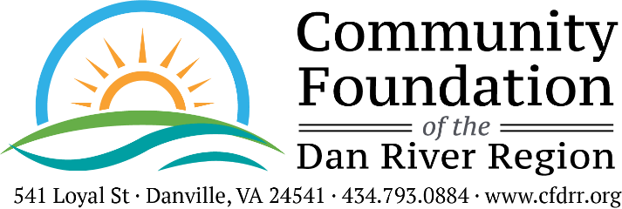
CONFIDENTIALITY POLICY
Board Approved September 27, 2021

POLICY

Any information about The Community Foundation of the Dan River Region and its applicants, grantees, donors, prospective donors, and any personal information about employees or other confidential information obtained as a result of working for or involvement with the Foundation shall be considered confidential and should be discussed only as appropriately required in connection with the Foundation’s work. All information concerning an applicant, grantee, donor, prospective donor, or other confidential information must be maintained in confidence, and particular care must be taken to avoid discussion of Foundation affairs with third parties, unless authorization to do so is obtained from the President, or as required by law.

All files, documents and working papers of the Foundation are the property of the Foundation. Any employee or Board member who purposely, or through a failure to exercise reasonable care, causes confidential information to be disclosed, unless such confidential information has been previously disclosed publicly, will be subject to disciplinary action, up to and including termination or discharge from the Board. The obligation to keep information confidential continues even after an employee/Board member ceases to be employed by the Foundation or ceases service on the Board.

Personal Addresses – It is the policy of the Foundation not to give our staff, donor, or Board members’ personal addresses or phone numbers to outside persons (with the exception of the human resource department’s dealings with benefit providers). Anyone asking for personal information on staff or Board members should be instructed to forward all calls, mailings or invitations to the Foundation office.

AGREEMENT

By signing below, I acknowledge that 1) I have received a copy of the Confidentiality Policy; 2) I have read and understand the Policy; and 3) I agree to abide by this Policy in my role as an officer, director, contractor, or employee.

I acknowledge and agree that all confidential information and grant files, contribution files, donor records, donor lists, charitable gift information, resource development data, manuals, letters, contracts, agreements, notes, notebooks, records, reports, memoranda and all other Foundation materials, documents and data used, prepared or collected as part of my work or involvement with the Foundation, in whatever form, are and will remain the property of the Foundation.

Accordingly, I agree that at the end of my relationship with the Foundation, I will destroy or return to the Foundation all Foundation documents and other materials of any kind which constitute or contain any confidential information, in my possession or control, regardless of how stored or maintained, including all originals, copies and compilations and all information stored or maintained on computer, tapes, discs, E-mail or any other form of storage.

Signature _________________________________________________ Date ______________________

Printed Name _____________________________________________

