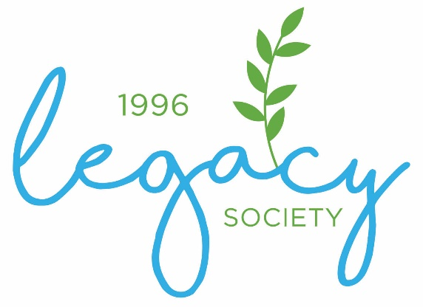

The Community Foundation of the Dan River Region
541 Loyal Street, Danville, VA 24541 (434) 793-0884 www.cfdrr.org
The Legacy Society is a way for The Community Foundation to honor those who have made a lasting commitment to the Dan River Region since we were formed in 1996. Individuals who designate a gift to The Community Foundation through a will, trust, or other planned gift are invited to join our Legacy Society.
Membership is voluntary and free. Gifts of all sizes are important and welcome. Disclosure of gift amount or type is not required. Legacy members will be celebrated at an annual Legacy Society reception. Members will also be recognized in publications and receive invitations to other Foundation events.
Please return the form below to be one of the first members of The Legacy Society!
---------------------------------------------------------------------------------------------------------------------
Name(s) ____________________________________________________________________
Address _____________________________________________________________________
City _________________________________ State __________________ Zip ____________
Phone _________________________ Email ________________________________________
____ I confirm that I have taken steps to make a planned gift in recognition of my strong confidence in the future of The Community Foundation and the region it serves.
____ Please include me as a member of The Legacy Society with the opportunity to participate in special programs or events. List my name (and/or my spouse’s name) for recognition in publications and at events and follows: _____________________________________________

____ I (we) prefer to remain anonymous. Please do not publish my (our) name.

____ Please contact me to discuss my current arrangements.

____ I (we) are interested in learning more about including The Community Foundation in our estate and beneficiary planning. Please contact us to discuss our options.

Contact us at 434-793-0884 for any further information.

