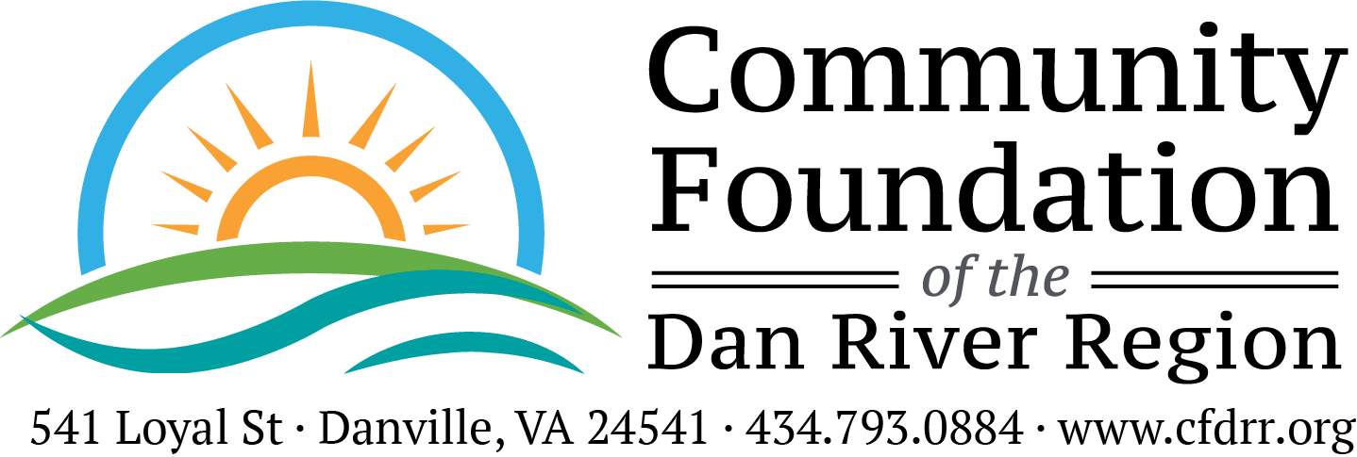

AUTISM EDUCATION FUND FINAL GRANT REPORT FORM
Please complete and return within 30 days of completion of the project but no later than March 31, 2024 to The Community Foundation, 541 Loyal Street, Danville, VA 24541.

Reporting Organization: ________________________________________________________

Project Purpose: _______________________________________________________________

Amount of Grant: ________________________ Date of Grant: ________________________

- Fiscal Report: How were the funds expended? Please be as specific as possible by attaching a summary of expenses along with copies of cancelled checks and receipts. Any remaining or unaccounted for funds must be returned to the Community Foundation by March 31, 2024.

- Impact Statement: Please describe the impact the Foundation's grant had on your program as well as the community as a whole. Attach one additional sheet of paper explaining the impact of these funds. Be specific. Give examples.

Photos: If available, please send project or general photos of your organization. E-mail photos to traci@cfdrr.org, or mail a hard copy to The Foundation’s office.

Person completing form: ________________________________ Title: ____________________
Phone: ______________________________________________ Date: ____________________

