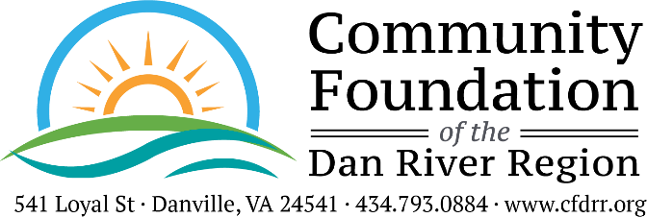

ARTS & CULTURAL FUND
2023 FINAL GRANT REPORT FORM
Please complete and return upon 30 days of completion of the project but no later than August 1, 2024, to The Community Foundation, Attn: Traci Petty, 541 Loyal Street, Danville, VA, 24541.

Reporting Organization: Organization Name

Project Purpose: Project Purpose

Amount of Grant: Grant Amount
Date of Grant: Grant Date

- Fiscal Report: How were the funds expended? Please be as specific as possible by attaching a summary of expenses along with copies of cancelled checks and receipts. Any remaining or unaccounted for funds must be returned to the Community Foundation by December 15, 2023, as stated in the Performance Grant Agreement that your Board President signed.
- Impact Statement: Please describe the impact the Foundation's grant had on your program as well as the community as a whole. Attach one additional sheet of paper explaining the impact of these funds. Be specific. Give Examples. Address the following:

  - Need or opportunity that was met or problem solved.
  - Outcomes including increased knowledge or changed behavior and measurements used.
  - Challenges encountered with the project/program and how they were addressed.
  - Additional information or comments.

- Program Population Served Report: The Foundation requires demographic data for the population served by your grant-funded program/project. Please submit the total number of people served, and break this information down by race, age, and gender. An editable Population Served Report Form is available on our website, and organizations should use this form to complete the requirement.

Photos: If available, please send project or general photos of your organization. E-mail photos to traci@cfdrr.org, or mail a hard copy to The Foundation’s office.

- Provide a one or two sentence statement sharing how this grant has changed or touched lives.

Brief impact report

This form is available for download as a Microsoft Word document at https://www.cfdrr.org/grants/applying-for-a-grant/

Person completing form: Person Completing Form Title: Title Of Person

Phone: Contact Number Email: Email Address Date: Date

